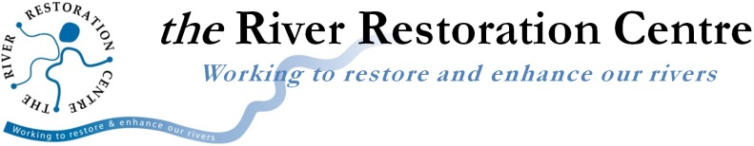

the River Restoration Centre - Board of Directors vacancies
Become a director on the RRC Board - 2 positions available
Commitment - from 8 days per year
Remuneration: Unpaid voluntary. Reasonable travel expenses covered.
Closing Date: Weds 5th Jan 2022
Interviews: 17th or 18th Jan 2022

The RRC is governed by a non-executive Board of Directors who support the Managing Director and staff and are responsible for helping to set strategic direction and ensuring the proper operation of this not-for-profit company. We are looking for two new directors to join the Board and are seeking people with a strong interest in supporting the development of a healthy river environment.
Potential directors should identify with the purpose and aims of the RRC and be aware of the importance of the work that we do. They should also:
- have the skills, knowledge, and experience (as set out in the Director Profile) required to enable them to contribute to a diverse and effective Board which delivers a high standard of governance
- be alert to, and able to avoid, conflicts of interests in relation to their other duties, roles, and responsibilities
- be able to devote sufficient time to enable them to fulfil the responsibilities of a Board member
- be open to taking on further specific Board roles and tasks in the future
- be committed to approaching their role with rigour and objectivity and always conduct themselves in an impartial and respectful manner
The Board meets four or five times per year (a combination of online and in-person meetings) and directors are asked to contribute their specific skills to supporting the RRC in a relevant area for a further two to three days. Supporting RRC events such as site visits and the annual conference is encouraged. Expenses incurred in fulfilling these duties are reimbursed. Board members serve for three years on appointment, with the option of further three-year terms if mutually desired.
We are seeking directors who are interested in the water environment, river processes, integrated catchment management, flood risk/natural flood management, nature-based solutions, the UK water industry, or environmental policy, and who have (or wish to develop) non-executive board experience. Given that the Board’s work is principally focused on helping the RRC to be an effective and efficient company, applicants should also be interested in aspects of organisational management. We are particularly interested in hearing from candidates who have strengths in the following areas:
- Running membership schemes or membership organisations
- Marketing or business development
- Working with or within third sector organisations, preferably in the environment sector
- Working with or within ecological/environmental contracting organisations
- Flood risk and planning of the built environment
- Funding schemes for environmental projects
To apply, please send:

1. A covering note (not more than two pages) which summarises your suitability for the role. Within this you should outline:

a) Your personal qualities, attributes and competencies and how they relate to the Director Profile. Describe how you would bring these to the work of the RRC Board, using supporting examples.

b) Why you are interested in serving on this Board.

c) Any other information that you think may be relevant to this voluntary position, including declaring any potential areas of conflict.

d) Your current position and any other non-executive roles you hold, and have previously held.

2. A copy of your CV.

RRC Director Terms of Reference

Applications should be sent by email to rrc@theRRC.co.uk

The closing date for receipt of applications is 5th Jan 2022.

Shortlisted applicants will be invited to an online interview on 17th or 18th Jan 2022.

Final applicants will be invited to attend a Board meeting which will be held by Zoom on 27 January 2022, following which a decision will be made.

If you have any enquiries about the recruitment process, including matters relating to conflicts of interest, please contact Martin Janes, the Managing Director, on 01234 752979 or at martin@theRRC.co.uk or Christianne Tipping, the Chair of the Board, on 0121 445 6046 or at christianne.tipping@gmail.com

